# 



**Informatics Institute of Technology**

# **Object Oriented Programming**

# **5COSC019C**

**OOP Coursework**

W.S. Nirusha Shehani

Uow Number – w1912854

IIT Number – 20210218

**OOP video link -** [**https://drive.google.com/file/d/1_uyVgzmgr7NoKZNQTq17IdCFY2IjKpn3/view?usp=sharing**](https://drive.google.com/file/d/1_uyVgzmgr7NoKZNQTq17IdCFY2IjKpn3/view?usp=sharing)

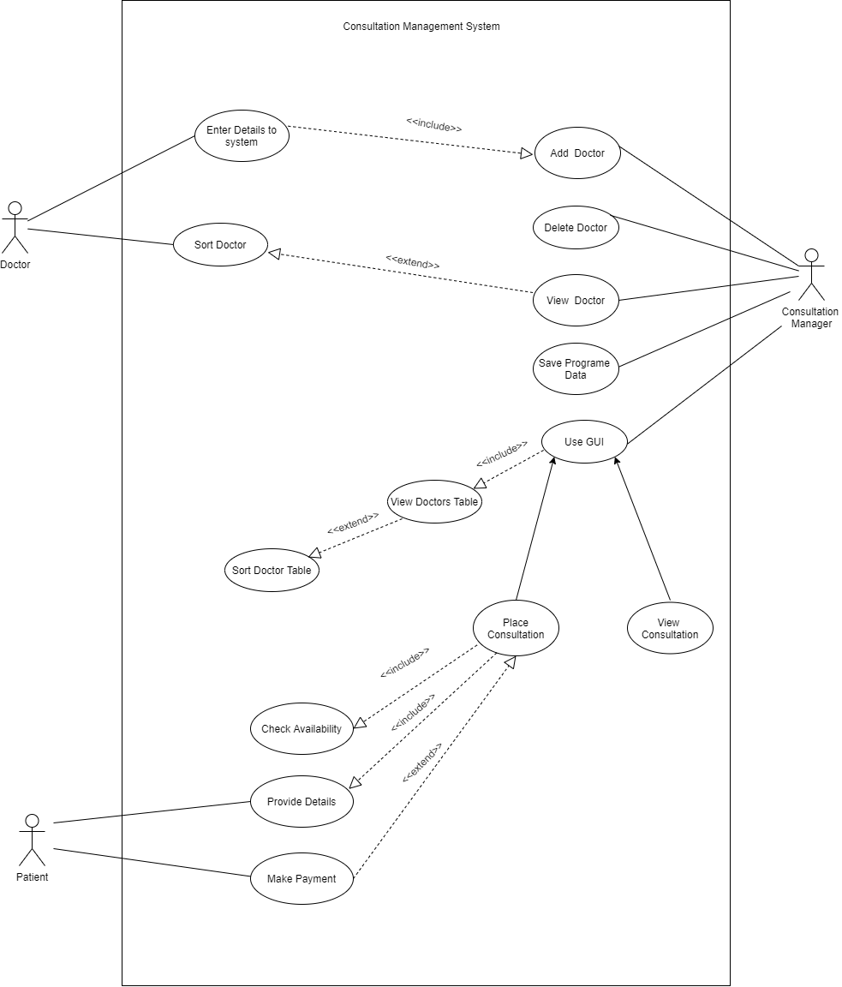

Student Name: Nirusha Shehani

Student ID: 20210218

|  |  |  |
| --- | --- | --- |
| Have you submitted the video with the demonstration of your system? | ✓Yes | No |

|  |  |  |  |
| --- | --- | --- | --- |
| **Test Case** | **Expected Result** | **Actual Result** | **Pass/Fail** |
| After program starts displays menu | Display menu | Display menu and  Let users insert options | Pass |
| (Add a doctor to the console menu)  Select A  Enter “Henry” for ‘First name of the doctor’ | Doctor First name added | Doctor First name added | Pass |
| Enter “Kulasinghe” for  ‘ Surname of the doctor’ | Doctor surname added | Doctor surname added | Pass |
| Enter “1999.08.25” for ‘Birth date of the doctor’ | Date of birth added | Date of birth added | Pass |
| Enter “678” for ‘License Number of the medical’ | Medical License Number added | Medical License Number added | Pass |
| Enter “0718899009” for ‘mobile Number of the doctor’ | Doctor mobile number added | Doctor mobile number added | Pass |
| Enter “Cardiology” for ‘Doctor Specialization’ | Doctor Specialization added | Doctor Specialization added | Pass |
| Enter ‘y’ to continue | If you want to continue press Y and press any key exit | Can continue adding doctors | Pass |
| Enter ‘any key’ to exit | Exit the code | Exit the code | Pass |
| (Delete a doctor from the console menu)  Select B  Enter “678” for ‘Enter the License number of the doctor that want to delete’ | Doctor with license number ‘678’ will be deleted | Doctor with license number ‘678’ has been deleted | Pass |
| (Print doctor list of the console menu)  Select C | Displays doctor details | Displays doctor details | Pass |
| (Save doctor list of the console menu)  Select D | Doctor details will be saved in a text file | Doctor details will be saved in a text file | Pass |
| Enter a letter except A, B, C, D | Continue the code | Continue the code | Pass |

|  |  |  |  |
| --- | --- | --- | --- |
| **Test Case** | **Expected Result** | **Actual Result** | **Pass/Fail** |
| (Open GUI of doctor list of the console menu)  Select E | Open the GUI | Open the GUI | Pass |
| Click ‘All Doctors’ | Display the doctor menu | Display the doctor menu | Pass |
| Click ‘Channel a doctor’ | Open Patient information and Consultation information | Open Patient information and Consultation information | Pass |
| Add patient and consultation information | Information added | Information added | Pass |
| Click ‘View all channel’ | Insert patient name and surname | Insert patient name and surname | Pass |
| Enter patient name and click ‘Submit’ | Open the booked consultation table with patient booked information | Open the booked consultation table with patient booked information | Pass |

**Phase 1 – Design and classes implementation**

|  |  |  |
| --- | --- | --- |
| **Task** | **Did you attempt the task?** | **Student’s comments** (To which extent you implemented the task? Have you encountered any problems or issue?) |
| Design a UML Use Case Diagram of your system (submitted in a separate file). | ✓Yes No | Complete the diagram with all use cases with relevant actors. |
| Design a UML Class Diagram of your system (submitted in a separate file). | ✓Yes No | Create the classes related to the program implementation with all the relationship include. |
| Implementation Class Person | ✓Yes No | Fully implemented and working completely. |
| Implementation Class Doctor | ✓ Yes No | Fully implemented and working completely. Extend the person class |
| Implementation Class Patient | ✓ Yes No | Fully implemented and working completely. Extend the person class |
| Implementation Class Consultation | ✓ Yes No | Fully implemented and working completely. |
| Implementation Interface WestminsterSkinConsultationManager | ✓Yes No | Fully implemented and working completely. GUI codes are also added to this class. |

**Phase 2 – Console menu implementation**

|  |  |  |
| --- | --- | --- |
| **Task** | **Did you attempt the task?** | **Student’s comments** (To which extent you implemented the task? Have you encountered any problems or issue?) |
| Add a doctor in the system with all the relative information (max 10 doctors) | ✓Yes No | Fully implemented and working completely. |
| Delete a doctor from the system selecting the medical licence number. Display a message to confirm he/she has been removed and the total number of doctors in the centres. | ✓Yes No | Fully implemented and working completely. |
| Print on the screen the list the doctors in the centre with all the relative information. The list should be ordered alphabetically. | ✓Yes No | Fully implemented and working completely. |
| Save in a file entered by the user so far. The user should be able to load back the information running a new instance of the application. | ✓Yes No | Fully implemented and working completely. |

**Phase 3 – GUI Implementation**

|  |  |  |
| --- | --- | --- |
| **Task** | **Did you attempt the task?** | **Student’s comments** (To which extent you implemented the task? Have you encountered any problems or issue?) |
| Doctor list visualisation. Sorting alphabetically. | ✓Yes No | Fully implemented and working completely. Show the GUI as required. |
| The user can select a doctor and add a consultation. | ✓Yes No | Fully implemented and working completely. |
| In the consultation the user can add all the patient details. | ✓Yes No | Fully implemented and working completely. |
| The user can select the date/time of the consultation considering that a doctor cannot have more than one consultation at the time. | ✓Yes No | Fully implemented and working completely. |
| The user can enter and save the cost for the consultation. (£25 per hour and only the first one £15). | ✓Yes No | Fully implemented and working completely. |
| The user can add some notes (text information or images). This information has been encrypted. | ✓Yes No | Fully implemented and working completely. |

**Phase 4 – Testing and system validation**

|  |  |  |
| --- | --- | --- |
| **Task** | **Did you attempt the task?** | **Student’s comments** (To which extent you implemented the task? Have you encountered any problems or issue?) |
| Test plan. (Submitted in a separate file). | ✓Yes No | Fully implemented and working completely. |
| Implementation of an automated unit test for each scenario in the console menu. | ✓Yes No | Fully implemented and working completely. |
| Error Handling across all the code, input validation and code quality. | ✓Yes No | Fully implemented and working completely. |